**Supplementary Materials:**

**Two-Dimensional Control of Rydberg Fragment Emission in Dissociative Frustrated Ionization of Oxygen**

**Junyang Ma1, Yongzhe Ma1, Pengzhao Wang1, Fan Yang1, Lei Xiong1, Yan Yang1, Hongcheng Ni1, [1]*, Jian Wu1,2,3, and Zhenrong Sun1, [2]‡**

*1State Key Laboratory of Precision Spectroscopy, School of Physics and Electronic Science, East China Normal University, Shanghai 200241, China*

*2Collaborative Innovation Center of Extreme Optics, Shanxi University, Taiyuan, Shanxi 030006, China*

*3CAS Center for Excellence in Ultra-intense Laser Science, Shanghai 201800, China*

**Dissociative single ionization of oxygen**

Figure S1(a) presents the momentum distribution of ionic fragments O+ resulting from the dissociative single ionization of oxygen in the polarization plane of the OTC laser fields, integrated over the relative phase *ϕ*L. Note that the events concentrated within the green dashed ellipse in Fig. S1(a)-(c) are attributed to the single ionization of water molecules in the background. This background signal is difficult to eliminate using momentum conservation because the neutral fragments O generated in the dissociative single ionization of oxygen cannot be detected by the detector. To better characterize the momentum distributions, the KER-dependent momentum angular distributions of O+ are displayed in Fig. S1(b). Four-lobed momentum distributions are observed for both the low-KER (0.2 eV < KER < 0.6 eV) and high-KER (1 eV < KER < 1.5 eV) regions, similar to that of O∗ from the dissociative frustrated single ionization of oxygen. Interestingly, O+ ejects along the polarization axis (*y*-axis) of the second harmonic field at the low-KER region, accessed by second harmonic photon-coupled transitions. This feature is not observed in the dissociative frustrated single ionization of oxygen, indicating a negligible electron recapture probability when the fragmentation occurs along the *y*-axis. Taking the OTC fields with an absolute phase of 0 as an example, a plausible explanation is that the dissociation along the *y*-axis is enhanced when the laser field vector of OTC laser fields points to the *y*-axis. However, the associated vector potential increases at the same time, as discussed in the main text (Fig. 4), resulting in a minor recapture probability for the released electrons with high velocity. It is noteworthy that this intriguing difference in the momentum distributions between the two channels is difficult to observe in a one-dimensional polarized laser field.

Figure S1(c) illustrates the *ϕ*L-dependent yield of O+ as a function of the emission direction *ϕ* at the low-KER region, revealing clear phase-dependent oscillations. To highlight the asymmetric emission of O+ steered by the phase controlled OTC laser fields and to exclude the measured events that cannot be directionally manipulated by the laser field (such as the single ionization of water in the background), we define the asymmetry parameter as $Asy\left(φ,φ_{L}\right)=\left[N\left(φ,φ_{L}\right)-N\left(φ,φ_{L}+π\right)\right]/[N\left(φ,φ_{L}\right)+N\left(φ,φ_{L}+π\right)]$, where $N\left(φ,φ_{L}\right)$ is the O+ yield at emission angle *ϕ* and phase *ϕ*L. Figure S1(d) shows the pattern of asymmetry parameter as a function of *ϕ*L and *ϕ* for ionic fragments O+ emitted in the low-KER region. Clear asymmetries are visible for ±45° and ±135° regions, corresponding to the four-lobed structures in Fig. S1(a)-(b). This interesting feature is consistent with that observed in the dissociative frustrated single ionization of oxygen, supporting the scenario of dissociative frustrated tunneling ionization.

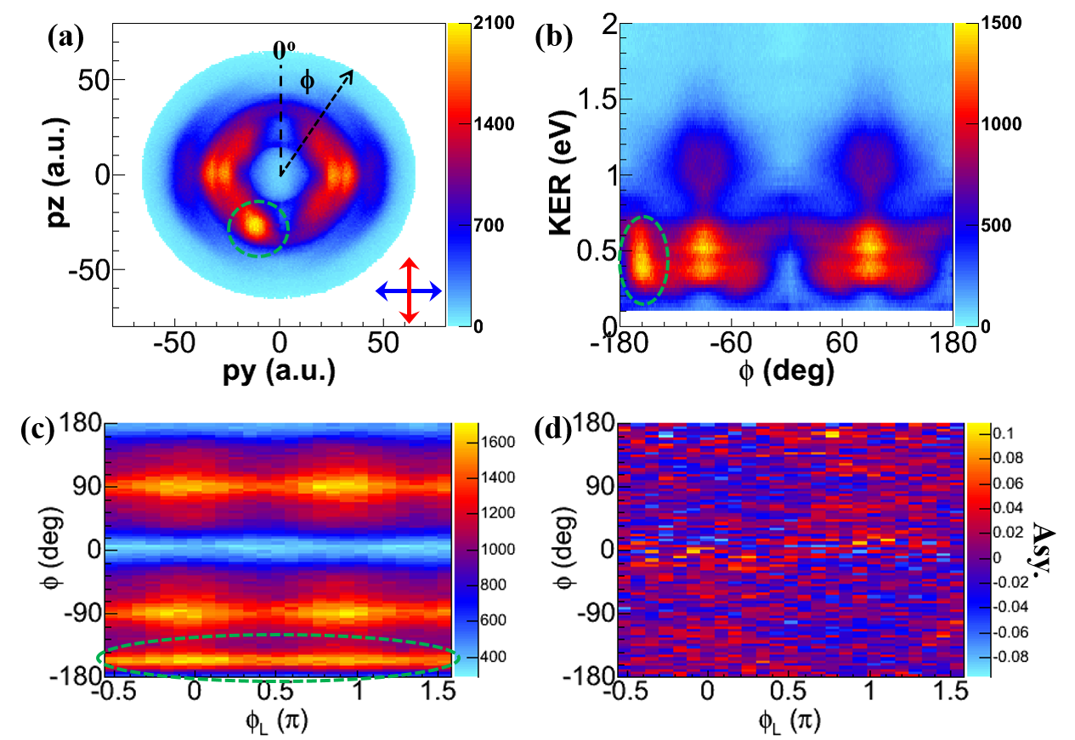

**Fig. S1**. (a) Momentum distribution of emitted O+ from the dissociative single ionization of oxygen. (b) KER of O+ versus its emission direction *ϕ*. (c) *ϕ*L-dependent yield of O+ as a function of the emission direction *ϕ* in the low-KER region. (d) Measured asymmetry parameter as a function of *ϕ*L and *ϕ* for ionic fragments O+ emitted in the low-KER region. The measured events concentrated within the green dashed ellipse are caused by the single ionization of water molecules in the background.

**Low and high excited states**

In experiments, Rydberg fragments with high principal quantum numbers are measured, while both low and high excited states are included in the theoretical simulations. To ensure consistency, we theoretically analyzed the results of different ranges in the principal quantum number, as shown in Fig. S2. We clearly see that electrons have greatest probability of being captured in low excited states (*n* ≤ 20). As the principal quantum number *n* increases, the probability of electrons being recaptured decreases. Remarkably, whether in low or high excited states, the results consistently exhibit asymmetric emission patterns in Rydberg fragments. Therefore, our numerical simulations indicate that the experimental data here could represent the behavior of the “dissociation frustrated ionization”.

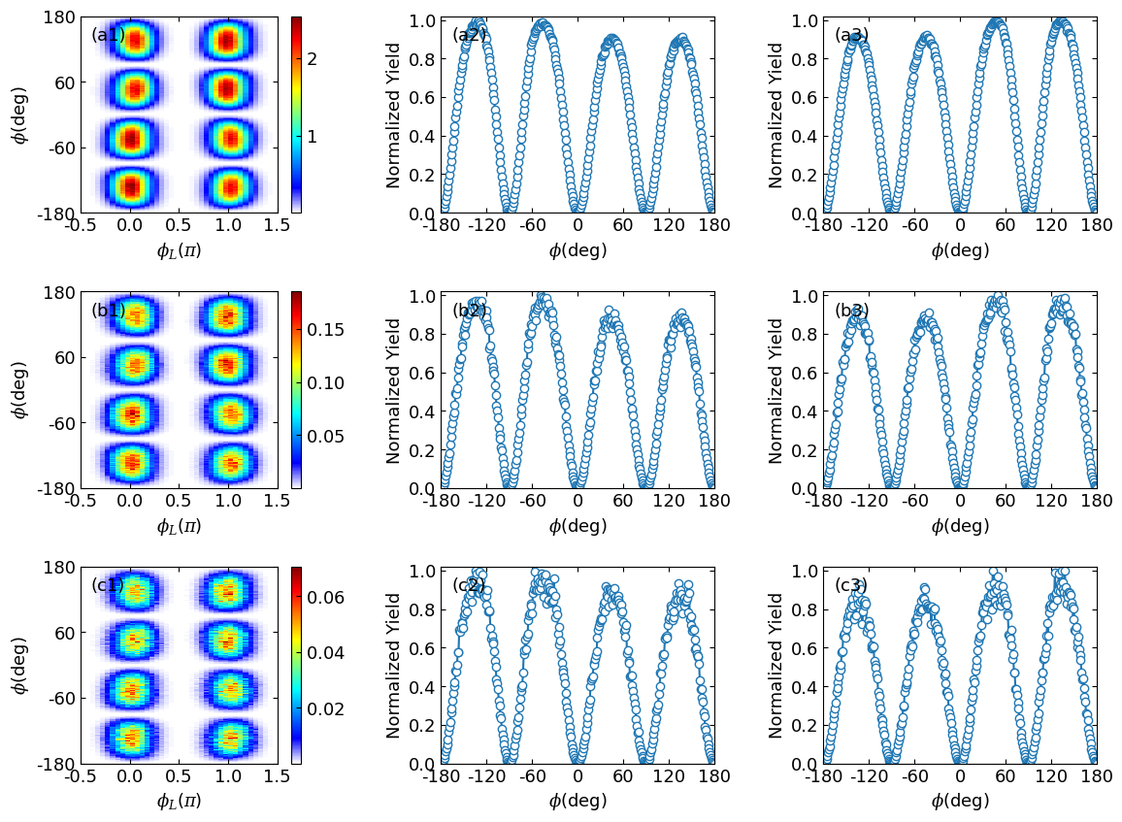

**Fig. S2**. (a1) Angular distribution of O* as a function of *ϕ*L for low excited states (principal quantum number *n* ≤ 20). (a2) and (a3) represent the integrated angular distribution of O* with *ϕ*L centered at 0 and π, respectively. (b) and (c) are the same as (a), but correspond to excited states with ranges of the principal quantum number 20 < *n* ≤ 40 and *n* > 40, respectively.

1. * hcni@lps.ecnu.edu.cn
2. **‡** zrsun@phy.ecnu.edu.cn